

**National University**

**School of Engineering and Computing**

**The Wellness Team**

**Team Members**: Aditi Bhujbal, Stefan Francisci, Shila KC, and Jennifer Knight

**In Collaboration** with Dr. Barbara Lauridsen, Instructor

**ANA 655** - June 2022

**Project Portfolio – Integrated Paper**

June 24th, 2022

***Part 1 – Concept paper (Submitted in week 1 on June 15th, 2022)***

**INTRODUCTION:**

Based on the application that was previously designed by our team, we propose to design a data mart for an eCommerce wellness site that will take information from a transactional database and record information about customers, sales, wellness coach performance, product evaluations, suppliers, and business financials

This prototype will be simple to begin with, with the ultimate goal of growing our capabilities to provide wellness and health solutions to the entire North American market. Our data mart will be used to analyze customer, sales, and performance data so we can build a profitable business based on our continuing assessments of these metrics.

Our wellness company consists of three main departments: fitness equipment sales, health supplements sales, and wellness coach advice that will assist customers who need wellness support or have questions about our products.

We do not manufacture any products ourselves, but we do ensure there is an extremely high symbiotic relationship between our customers and our suppliers.

There are three main goals our customers wish to achieve when they approach our company. Some wish to lose weight, some wish to become healthier or feel better, and others wish to be supported as they purchase high quality products to enrich their lives.

When customers sign up for one of our free memberships, they create a profile that helps us understand what they hope to gain from our company. From this initial profile, the customer is assigned to a wellness coach who is devoted to providing the best possible service to help them achieve their goals. We also retain this data for further product selection analysis.

Some customers are looking for ethically sourced exercise clothing and equipment to purchase and use when they work out at home. Others are looking for supplements that will help them reach their health goals, and still others are looking to purchase high tech home workout equipment that will allow them to have a satisfying personal trainer experience at home.

From this transactional database, we will create a data mart that will help us better understand our customers' goals and needs. For the pilot, typical complaints or endorsements will also be collected in the operational database. We will run an analysis to identify which products do not meet our company standards or are not profitable at certain price points.

Initial logical ERD model of one of the operational sources is to determine our customers’ needs and response to our products and is as follows:

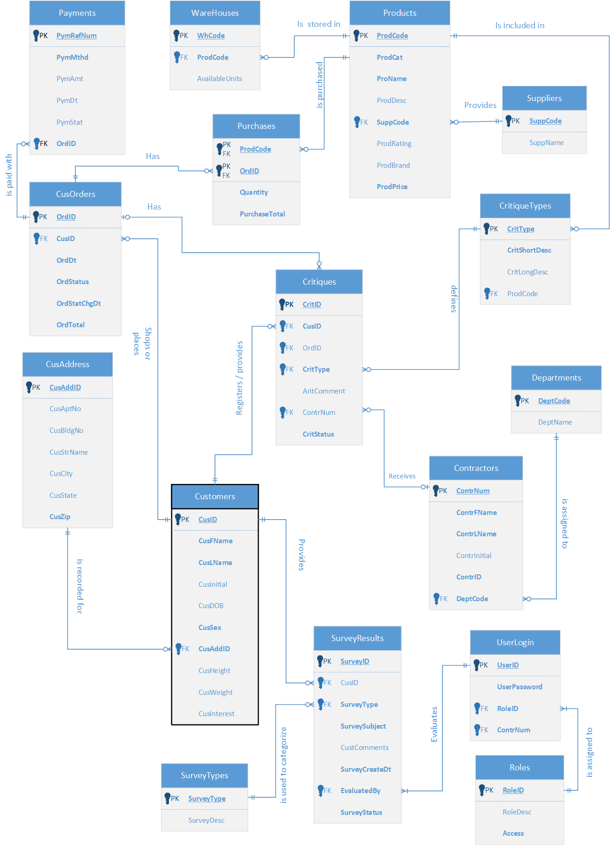

ERD diagram originally created in Visio for ANA650

Authors: Aditi Bhujbal, Stefan Francisci, Shila KC, and Jennifer Knight

Further refinements of the model will be done.

From a BI perspective, our customer sales and reviews can be used to determine what products we sell are either unattractive to our customers, or do not meet their needs. We will also track wellness coach performance in our data mart so we can determine which coaches may need extra training to maintain our high customer service standards. We will also track good performance to incentivize our wellness coaches who receive good customer critiques.

We understand that when customers first encounter our business, they might not yet know what services we offer. Therefore, we include a variety of surveys which will help customers understand how our company can support them and encourage them to meet their wellness goals.

An example of our supplement services will be similar to that of this survey found on [WebMD](https://www.webmd.com/vitamins-and-supplements/supplements-assessment/default.htm). Data from our surveys will be retained so that business outcomes can validate customers’ experiences.

[](https://www.webmd.com/vitamins-and-supplements/supplements-assessment/default.htm)

[](https://www.webmd.com/vitamins-and-supplements/supplements-assessment/default.htm)

*Images sourced from* [*WebMD.com*](https://www.webmd.com/vitamins-and-supplements/supplements-assessment/default.htm)

Our home fitness survey will be geared towards the home workout market and will help customers choose home fitness equipment. It will be similar to this survey which can be found at [bowflex.com](.%20https:/www.bowflex.com/blog/perfect-workout-personality-quiz.html)

[](.%20https:/www.bowflex.com/blog/perfect-workout-personality-quiz.html)

*Image sourced from* [*Bowflex.com*](.%20https:/www.bowflex.com/blog/perfect-workout-personality-quiz.html)

**OBJECTIVE AND PROBLEM TO SOLVE**

Importing operational transactions into the data mart will allow us to store inventory, product sales, survey findings, product reviews and complaints/critiques, and show us “the big picture”, including:

* What our customers are looking for?
* What products and wellness coaches provide excellent service?
* What products and wellness coaches provide poor service?
* Which products are profitable, and which are not?
* Which suppliers provide the best products?

We will use this information to see what products and promotions offer the best sales and profits in different areas of our sales market.

**CHALLENGES**

Some challenging aspects of our design are how to determine which products and employees are performing poorly, and which perform well, but have customer complaints through misuse or poor customer follow through. (It’s easy to blame the product or sales representative, but could it be that the customer did not use the product properly?).

We will need to have in-depth complaint reviews that are capable of determining if the customer complaint is valid, and to determine if products need to be removed if they do not meet quality standards. Our organizational goal is a high level of customer satisfaction.

In order to provide the best range of reviews, we will also email requests for customers to rate the products and services that they have ordered and received. This data will be extracted from our transaction database and aggregated into “Product Ratings”, and then be stored in our data mart for managerial review to ensure we are providing the best possible products and services.

Another challenge is that we will be offering health guidance. We want to be sure that customers understand we are not doctors and are not offering medical advice; we are simply working with them to help them achieve their health and fitness goals.

Even though we are offering no medical advice, we will have a medical doctor on staff that reviews all of our posts and listings to ensure that our literature and product descriptions are medically sound.

Our data mart will be an informational pipeline we can use to help us make sound business decisions that will help us grow our eCommerce wellness business, ensure we are profitable, and provide a high level of customer satisfaction.

***Part 2 – submitted on June 23rd, 2022 (Revised to incorporate Green comments)***

Based on our previous concept, the Wellness Team is moving forward with our data mart construction. We will explore potential operational sources, explain our ERD diagram, draft our assumptions about business rules, and create a data dictionary.

**EXPLORE OPERATIONAL SOURCES**

We started exploring our operational model with this eCommerce workflow diagram. It shows our basic company structure and details the relationships between our customers and major departments.

[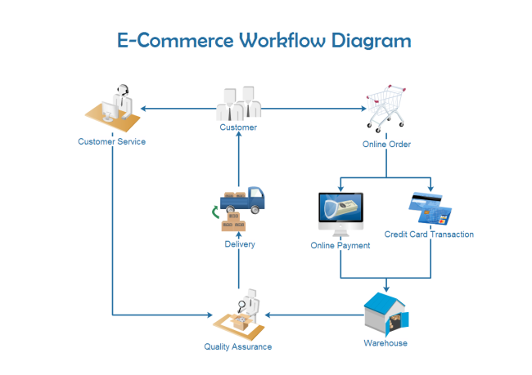](https://www.edrawsoft.com/template-e-commerce-workflow.html)

[Image sourced from edrawsoft.com](https://www.edrawsoft.com/template-e-commerce-workflow.html)

As we can see, when a customer enters our online store, they have three options. They may either create an online order or contact one of our wellness coaches (represented by customer service) who will assist them with any questions they may have and make recommendations to support the customers wellness goals, or they may merely explore options and leave the session with no action.

It is our goal to capture click stream data as well as another source of operational data. With this additional data, we can gain further insight into our website's navigations that result in sales activity or lack of page views. Also, information on referring partner links that lead to vendors and suppliers will add additional information on site statistics and customer behaviors. This additional data will yield further insight into customer types, and product performance.

As seen in the image below, events are captured for later analysis by the end users. The information retrieved can then be used for strategic decision making on products or to anticipate future demand.

[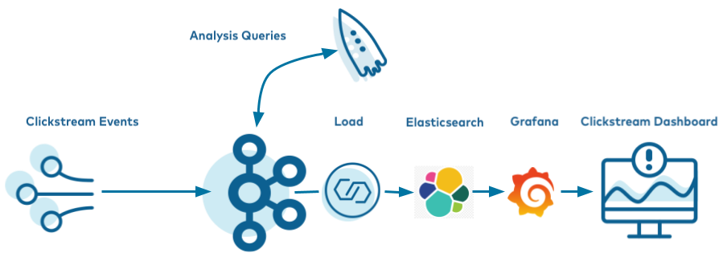](https://docs.confluent.io/platform/current/tutorials/examples/clickstream/docs/index.html)

[Image Sourced from Confluent Developer](https://docs.confluent.io/platform/current/tutorials/examples/clickstream/docs/index.html)

Due to the amount of data that will need to be collected and processed once our clickstream source is implemented, we will have to implement artificial intelligence processes to leverage this form of real time data. Here is an excerpt taken from Stefan’s Week 2 paper discussing the capturing and processing of real time data such as clickstream and leveraging artificial intelligence capabilities to yield business intelligence outcomes:

In this grand age of information, the amount of data needed to be stored is only accelerating and business are starting to realize that they can make informed strategic decisions with real time data. Molander writes “we see that an increasing number of companies are investing in real-time infrastructure as they’re going from being data-driven (making decisions based in historical data) to becoming data-led (making decisions based on real-time and historical data). Good indicators of this trend is the blockbuster IPO of Confluent and new products such as Clickhouse, Materialize and Apache Hudi that offers real-time capabilities over data lakes.” Businesses are seeing value in capturing real time data as it could potentially solve current problems or provide insight into current operations. But where does AI come into play with real time data capturing. The benefits and impacts can be immediate as noted by Maric Tchakarov, CEO of Kindred. “ Making data real-time is one way AI can add or bolster resilience in a supply chain, Tchakarov says. First, increasing the speed of that data helps throughput, creating a buffer. Second, managers can know right away of labor shortages or workforce ebbs and flows due to illness, weather, or natural disasters.” So, AI can speed up the process of gathering the right information to support business operations. Here is a brief snapshot of how it works:

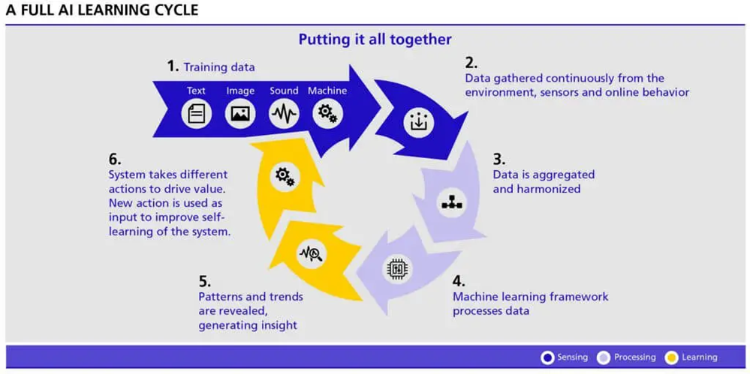

[Image Sourced from Transmetrics](https://www.transmetrics.ai/blog/ai-in-logistics/)

This powerful tool is one that learns patterns in data and through learning algorithms, and then improves its own processes for extracting the data. The illustration above demonstrates this in a cyclical format where training data is first used in addition to data being gathered, which is all then “aggregated and harmonized” or gone through the ETL process. Learning algorithms are then performed to reveal patterns and trends before the system analyzes and then improves on what it just did. That’s why it has predictive qualities as well, it learns and interprets events as they are happening. Kelly Matthews of IoT Times summarized the benefits of incorporating Artificial Intelligence and real time data as follows:

* **Lean management and operations with improved output quality.**
* **Better target segmentation and a broader understanding of customer bases.**
* **Enhanced data catalog and governance compliance.**
* **Smarter employee experience and retention strategies.**
* **Predictive responses to various events — see them before they happen.**
* **Increased revenue and reduced operating costs through process improvements.**
* **More successful responses to customer trends and market changes.**

(Matthews. 2022)

As the volume of data that is generated grows over time, we clearly need technology like AI in combination with real time data to handle this ever-increasing digital phenomenon that we have created for ourselves. Particularly in business, executives are seeing the power in not only capturing the data in real time but also quickly processing it to inform themselves on the current state of their operations or warn them of future issues that may arise. These are the reasons why real time data warehousing in unison with Artificial Intelligence will continue to be a trend moving forward. The potential strategic insights provided by this technology can be crucial if not indispensable for the modern large business. Real time data is powerful in terms of its capabilities for capturing data that can produce strong business intelligence results. Being able to derive customer behavior through their clicks along with site functionality statistics is crucial for a large-scale E Commerce business. By leveraging the real time data complimented with artificial intelligence, we will be able to not only correct issues such as failing active marketing campaigns as they are happening, we will also be able to forecast potential issues related to supply chain and product demand.

Surveys will also be available to help customers figure out what products would work best for them, and quality assurance standards will be used to ensure that our wellness coaches are providing correct information to our customers.

If a customer orders a product, they will provide a debit or credit card, or use PayPal to pay for their completed order. Once the payment is approved, the order will be sent to the warehouse, where an employee will examine the product (i.e., check expiration dates on packages and ensure that other products are not damaged) and then the purchased products will be packaged and shipped to the customer.

Customer critiques and surveys are a vital part of our company and will be used as a quality assurance method to ensure we are providing a high level of customer service. This will also serve to evaluate the demand and utility for all products. This process ensures that our own warehouses are restocked so future orders can be fulfilled.

The diagram below shows how our Wellness Company will manage social media posts and reviews. This flowchart designates the actions we will take when a customer leaves a critique.

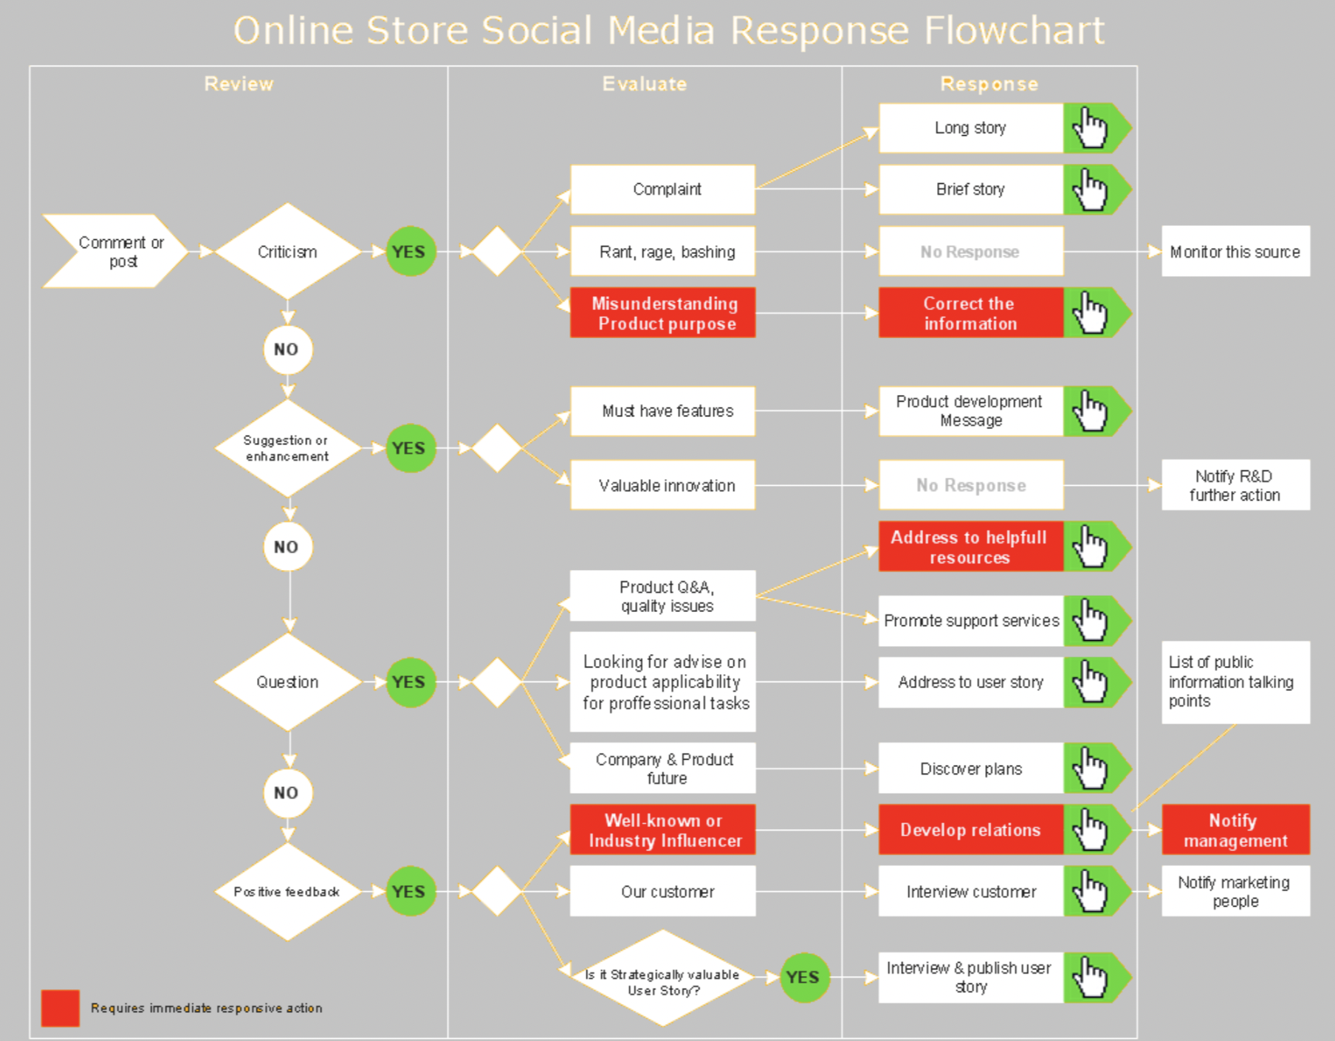

[Image sourced from conceptdraw.com](https://www.conceptdraw.com/How-To-Guide/picture/MARKETING-DIAGRAMS-Social-Media-Response-Online-Store-Social-Media-Response-Flowchart.png)

Customer critiques may be negative or positive. If we receive a negative review, we will determine the reasons behind it and take the approved action. For instance, if a customer is unhappy because they do not understand how the product should be used, we will respond and provide them with the correct product use information. Many of these communications will be conducted automatically and electronically.

If the customer is making a suggestion, we will pass the information along to the internal product manager who may share it with the supplier, or our research and development department. If a customer is asking a question, we will either immediately answer the question and provide support or conduct research to find the answer and then relay the information back to the customer.

If we receive positive feedback from a customer, we will attempt to establish a relationship and, if the customer approves, pass the customer information on to the marketing department in order to create goodwill and promote our business and products.

**ERD OF OPERATIONAL SOURCE & EXPLANATION**

From these initial documents, we created the following logical ERD Diagram using Microsoft Visio. This model diagram includes two operational kinds of information: one for the ordering cycle, and the other for collecting customer satisfaction surveys.

|  |
| --- |
|  |

ERD diagram originally created in Visio for ANA650

Authors: Aditi Bhujbal, Stefan Francisci, Shila KC, and Jennifer Knight

Further refinements of the model will be done.

**Our Operational ERD model consists of 16 tables**:

*Table 1:* ***Customer Table***

This table is used to keep track of customer information. Each customer must have a unique customer ID. Each customer will have a first name, last name, gender, and address. When an order has been placed, a shipping address will be provided for business or home address so products can be delivered.

*Table 2:* ***SurveyResults***

This table is used to collect information on completed surveys so we can better understand our customers' wants and needs. Each survey must have a unique SurveyID. Each survey result will list the survey type, survey subject, survey creation date and status of a survey. It also records which user evaluated the survey. Each survey can be evaluated by one or many users.

*Table 3:* ***SurveyTypes***

This table is used to track and review survey types. Each survey type is unique and a survey can have only one type (i.e. supplement or exercise evaluation). Keeping track of this information will help us see what products our customers are most interested in.

*Table 4:* ***User Login***

This table keeps track of users. Each user must have a unique UserID. Contractors will have unique user login info. One person may have multiple user login credentials (i.e. if UserID remains idle for more than 90 days, it’ll be deactivated and new ID needs to be created for same contractor).

*Table 5:* ***Roles***

This table keeps track of what the role of a user is. Each RoleID has only one role, but one person may have one or many roles (i.e., a user may have the role of a manager and wellness coach as well). RoleID for each user reveals their relationship with the company (contractor, customer, etc.) and also manages what access they have to information (i.e. they see only product and customer information as a wellness coach, or more detailed business information as a business analyst or a sales manager).

*Table 6:* ***Contractors***

This table is used to manage our contractors’ details. They are required to have a unique identification number, First and Last Name, and department code. Each contractor may have zero or one DeptCodes and each code is unique to a department.

*Table 7:* ***Departments***

This table is used to manage our departments. Each department must have a unique department code and each contractor belongs to zero or one department.

*Table 8:* ***Critiques***

This table is used to manage our customer critiques. Each critique has a unique CritID, but one customer may have many critiques of many different types. This table contains the CritID, CusID, CritType, and CritStatus.

*Table 9:* ***Critique Types***

This table keeps detailed information about each type of critique and the product it refers to. Each critique type is unique (i.e. product critique or contractor critique). There can be multiple types of critiques for one product and customers may have many critiques. This table must contain the critique short description, and may also have a long description if required.

*Table 10:* ***Products***

This table keeps track of our products. Each product code will be unique, product category and product name provide more details about the product. In addition to them, this table must contain the supplier code and product price. (Note: Whenever an order fulfillment detects a shortage of stock on hand, an order from the SUPPLIER’s inventory may be released to complete the order.)

*Table 11:* ***Suppliers***

This table keeps track of our suppliers. Each supplier is identified by a unique code and can supply different products (Note: there may be zero records in **Products** table for a given SuppCode at the stage of supplier onboarding).

*Table 12:* ***Warehouse***

The warehouse table tracks our inventory for stock on hand, so we know what is available for order fufillments. Each Warehouse has a **WhCode** which is also a primary key, and a product is identified by a foreign key **ProdCode**, which is joined to the **Products** table for each product listed in or eCommerce system. This table also tracks the number of units available.

*Table 13:* ***Purchases***

The purchases table tracks each product and its quantity purchased in every order. There must be at least one record created per order in this table along with the total payment amount for a purchased item. This information will be summarized if multiple products are itemized on a single order. (Note: if CUSTOMER does not yet have a shipping address, when an order is fulfilled, a shipping address must be provided.)

Table 14: **CusOrders**

This table tracks customer orders. There is a unique order ID for each transaction and the required information is the customer ID, order date, order status, order status change date, and order total. Each customer may have many orders.

*Table 15:* ***Payments***

This table tracks customer payments. Each payment has a unique payment reference number and requires a payment method and order ID. A date for each payment must be recorded and may coincide with the purchase event.

*Table 16:* ***CusAddress***

This table tracks customer addresses. Each address has a unique ID. However, each customer may have multiple addresses, (such as for place or business, home or for billing or shipping). Also required in this table is the customer zip code.

**BUSINESS RULES ASSUMPTIONS**

* Sales are conducted only through our online store for customer visits for retail purchases (there are no physical locations).
* Sales are via debit card, credit card or paypal (we do not accept cash).
* All sales are in US dollars.
* Items will be shipped directly from the internal or suppliers’ warehouse using an outside delivery service (USPS, UPS, FedEx, etc.)
* Sales are complete after the company has received payment and the order is delivered. Thereafter, a set of financial transactions can be transmitted to our financial system.
* All transactions are conducted within North America (we may expand in the future).
* All database transactions shall be noted in Pacific Standard Time.
* Items in their original condition may be returned by customers within 30 days for a full refund.
* The inventory on-hand of the warehouse shall be updated when sales or returns are processed.
* Items are sent to customers from the closest warehouse facility.
* Orders will be normally shipped within 2 business days.

**DATA DICTIONARY**

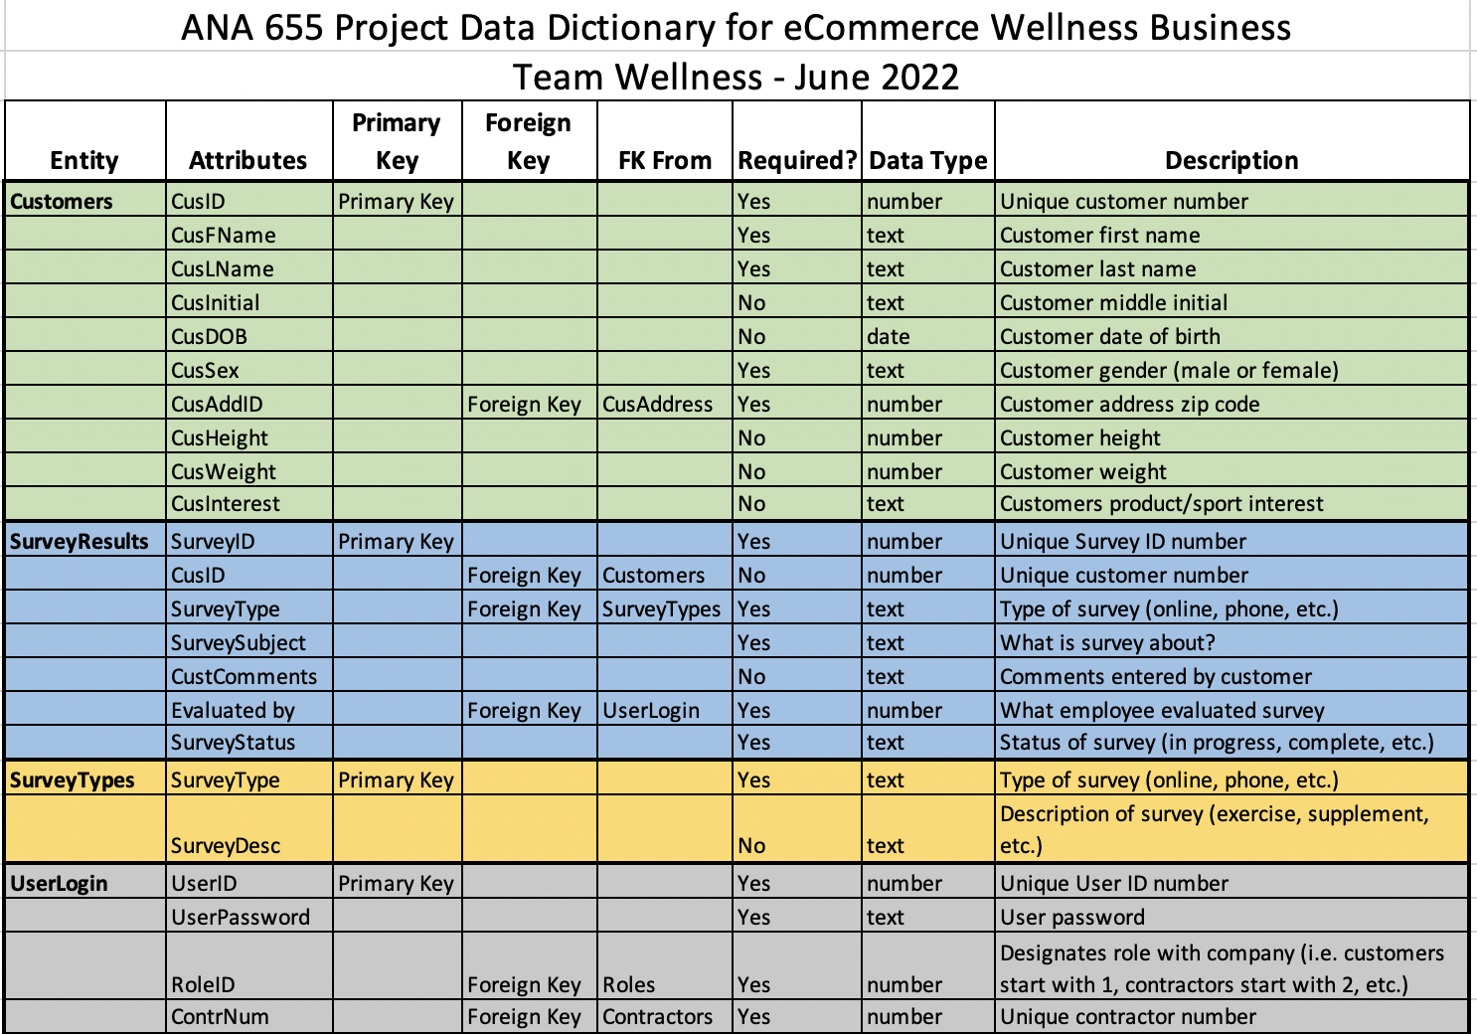

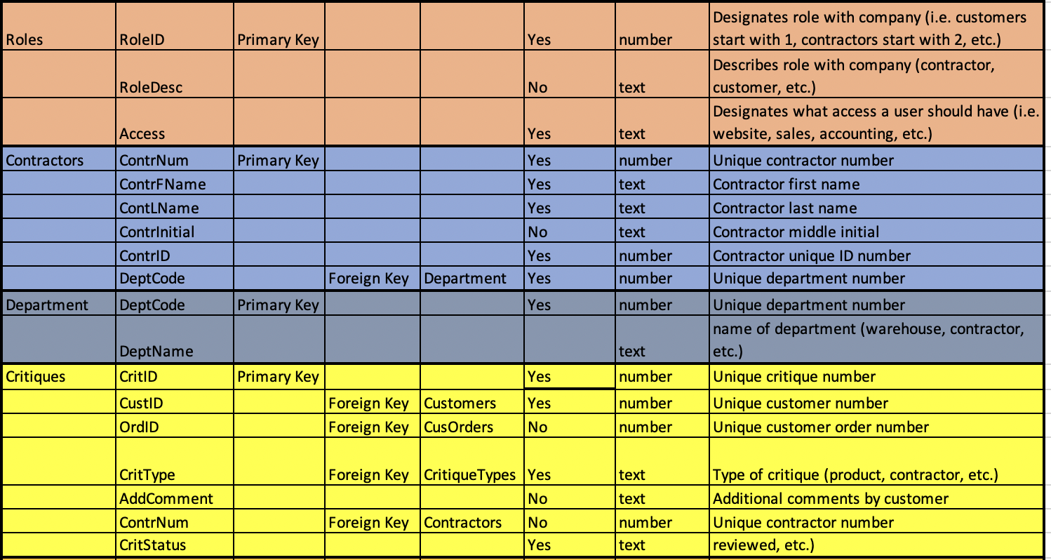

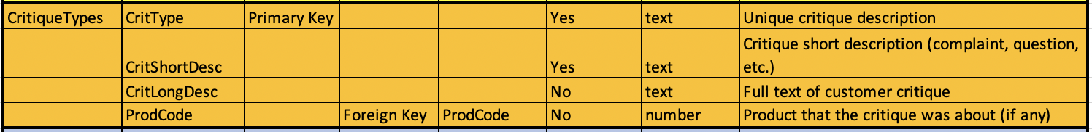

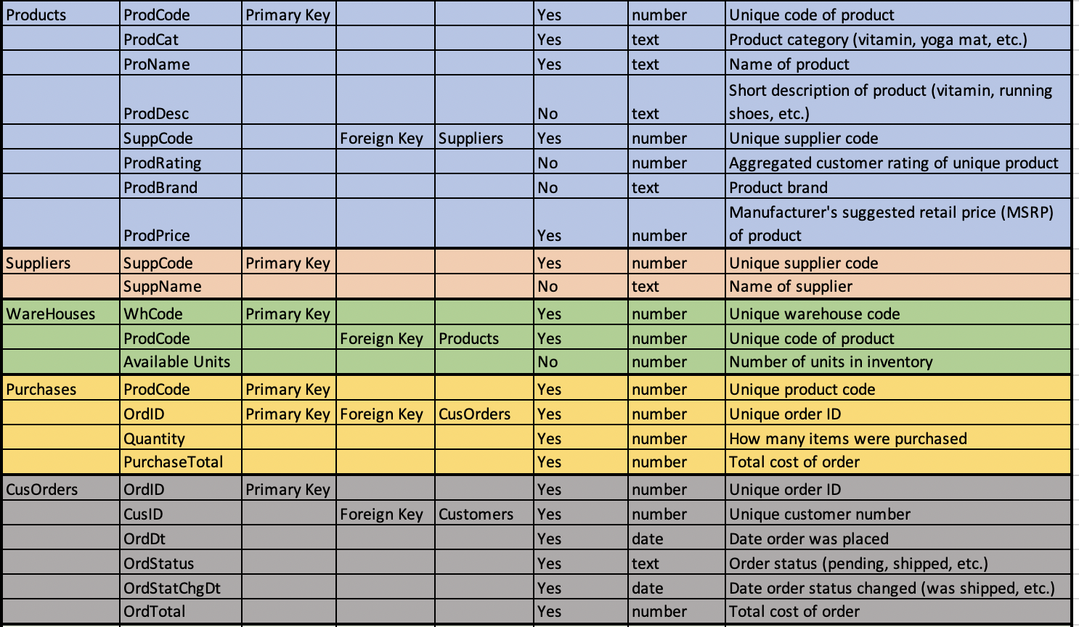

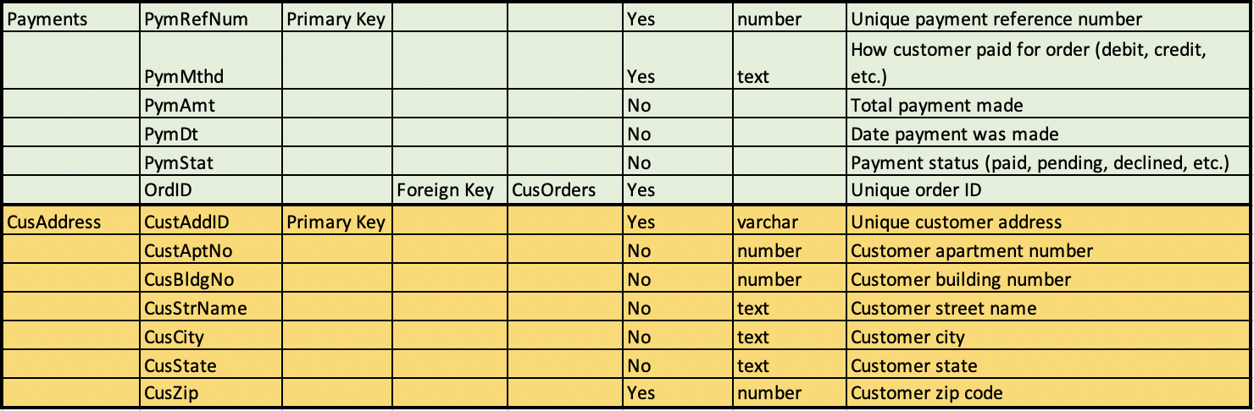

***Part 3 – Week 4 June 24th, 2022***

The following diagram shows The Wellness Teams most recent Operational ERD, which has been refined to fulfill Data warehouse requirements.

**Modifications made to previous model:**  
1) Modified name of all entities to plural e.g. Products, Employees, CusOrders.  
2) Added new attributes in Purchases table – Quantity and PurchaseTotal.  
3) Added new attributes to Products table – ProdBrand and ProdPrice  
4) Added new attribute to CusOrders table – OrderTotal.  
5) Removed ‘PymMthd’ attribute from CusOrders table and added ‘OrdID’ to Payments table to connect the two tables.  
6) Added new attribute to Payments table - PymRefNum and set it as primary key.   
7) Removed ‘primary key’ constraint from ‘PymMthd’ attribute in Payments table

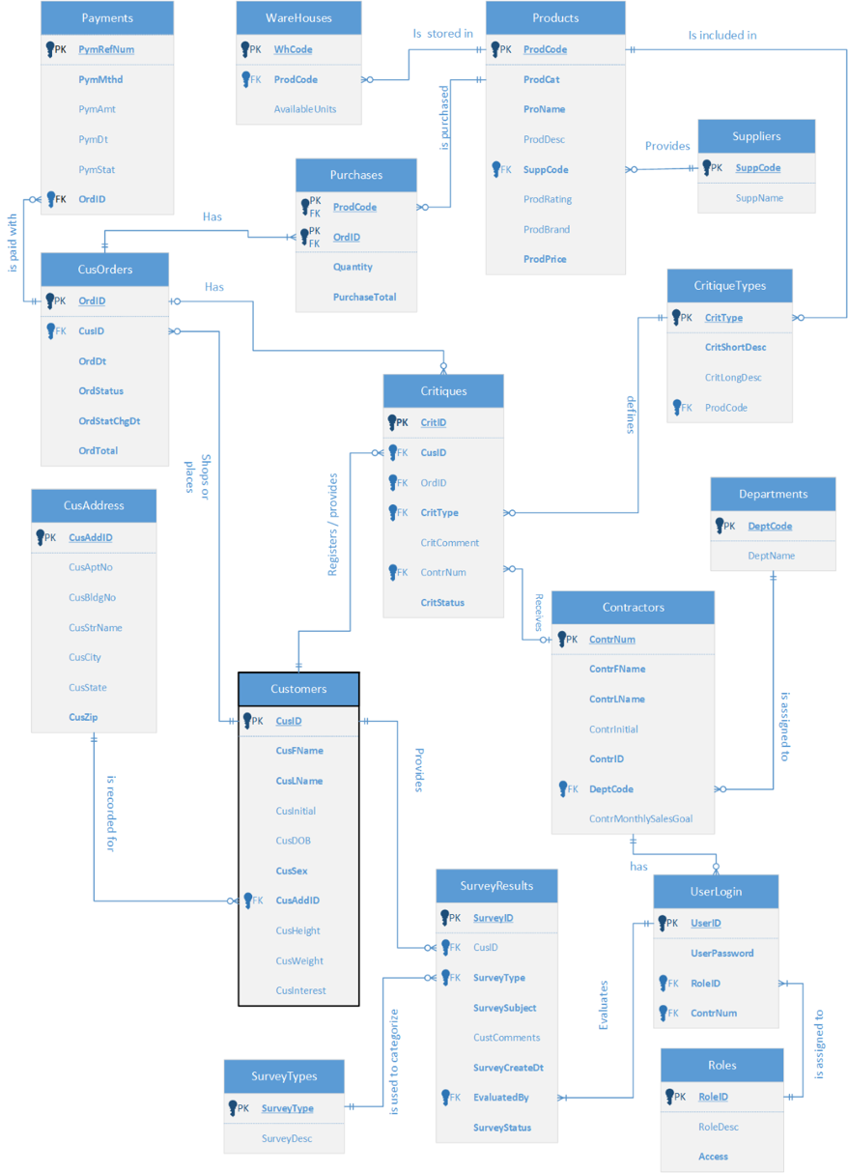

**WAREHOUSE SCHEMA (STAR):**

The image below shows the star schema design of a data warehouse that we propose to build in this project. There will also be a separate pdf file attached to this project showing the same star schema and an access file that will contain table design view and schema design.

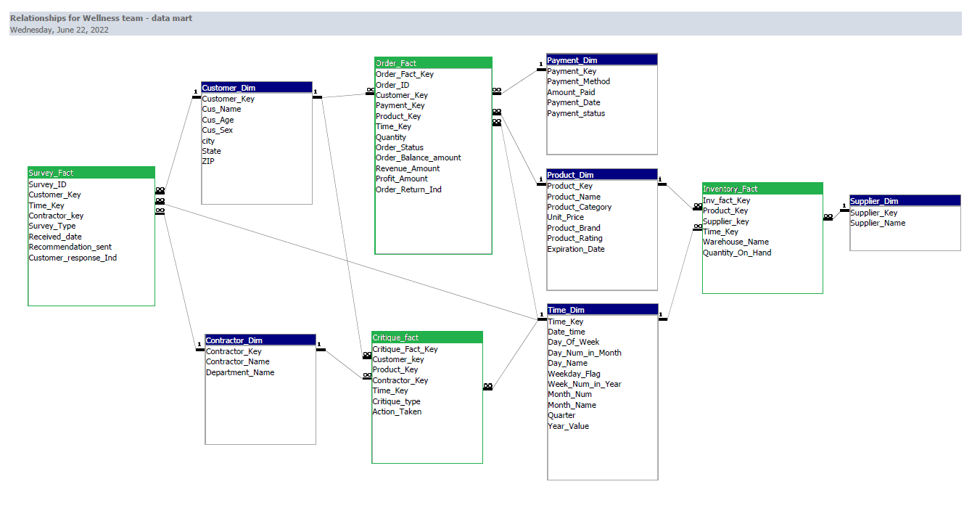

The schema was created by The Wellness Team. We referred to a paper by **Michał Drozdowicz** provided by instructor Dr. Barbara Lauridsen.

This star schema consists of **4 Fact** and **6 Dimension** tables.

**Fact tables:**

1. **Survey_Fact**: This table will store along with Survey_ID as PK and the measures of customer surveys along with their response (Positive/negative) on recommendations provided by wellness coach. **Customer_Key, Time_Key, Contractor_Key** are numeric keys that will connect this fact table to their respective dimensions. **Received_date** will be populated from SurveyCreateDt in SurveyResults of operational database. **Recommendation_sent** (Yes/No) and **Customer_Response_Ind** (positive/negative) will store the transformed data from SurveyStatus attribute of the same entity in operational db.

1. **Order_Fact**: Data from CusOrders table of operational database will be transformed and loaded into this table to measure metrics such as “Number of  orders in each status (placed/delivered/returned) per day”, “Top 5 products bought by customers per quarter”, “Product(s) that contribute to maximum returns in a month”, “Total revenue and profit of a year/quarter/month. Numeric keys will be stored to describe customer, product and payment details associated with the order, and Time_Key will contain information about the date and time of creation of a record into Order_Fact.

1. **Critique_Fact**: This table stores the data extracted from the Critiques table of our operational database. the data stored in Critique_Fact table will be useful to determine number of open critiques (complaints), number of endorsements received for a product or a wellness coach. Critique_Fatc_Key is a primary key to distinguish between each record in this table. Numeric key attributes are foreign keys to connect with Customer, Product, Contractor, and Time dimensions.

1. **Inventory_Fact**: The source of the data stored in this fact table is **Warehouses** table from operational database. It provides an insight about the quantity of each product on hand. Product_Key, Supplier_Key and Time_Key attributes connect the respective dimension tables to describe each item stored in this fact table. This data plays an important role in inventory management decisions.

**Dimension Tables:**

1. **Customer_Dim:** This table will containonly the required information of a customer such as Customer Name, Age, Sex from Customers table and City, State, Zip from CusAddress table in operational source. Customer_Key is a primary key to uniquely identify each customer. This data can be used to identify number of customers in each age group (young, adult, and old), number of Male and Female customers, grouping customers according to the state they reside in. and this data will also account for analyzing measures in fact tables it is connected to.

1. **Contractor_Dim:** Source of the data in this table is Contractors from our operational source. Primary key Contractor_Key is used as foreign key in Survey_Fact and Critique_Fact to describe contractors associated with the measures in them. It also contains Contractor_Name and the Department they belong to. This data can also be used to analyze number of contractors in each department.

1. **Payment_Dim:** This table provides more information about the payment and method used to pay the amount for each order. Payment_Key is a primary key of this dimension and is also stored as foreign key in Order_Fact. Attributes Payment_Method, Amount_paid, Payment_date and Payment_Status contains the data extracted from Payments table in Operational source. This data can also be analyzed to identify total amount received by each payment method or we can identify the method that customers prefer to use to pay for their orders.

1. **Product_Dim:** This table stores information that is relevant to products such as product name, category, price of a product per unit, brand, aggregated rating, and date of expiration. The Primary key of this dimension is Product_Key which connects it to Order_Fact and Inventory_Fact.

1. **Supplier_Dim:** This table containstwo attributesat this moment, Supplier_Key and Supplier_Name. **Supplier_Key** is the primary key and connects this dimension to Inventory_Fact. A question may arise that why a separate dimension just to store Supplier_Name instead of including the Supplier_Name in Inventory_Fact itself. The purpose of doing this is to accommodate future requirements to store location information of suppliers, average rating of suppliers based on rating to a product they supplied. This new data will be used to map the supplier to each product after identifying the supplier who provides the best quality of a product.

1. **Time_Dim:** Time dimension is important in a data mart to identify the most recent data loaded to it and is also useful in retention of data. In our model, Time_Dim contains Time_Key which is a primary key and will be recorded in each fact table with the most recent value. It also contains attributes to describe the time measurement such as Date and Time, day of a week, day number in a month, name of the day in a week, whether it is a weekday or holiday, Month, Quarter, Year, etc.

**SALES INCENTIVES SCHEMA:**

The image below displays a star schema that would be used to derive key performance indicators regarding wellness coach performance. From this data mart, we can view total recommendations and complaints related to specific wellness coaches as well as their sales performance. Conceptually, this was created to provide a monetary bonus for wellness coaches to earn by providing strong customer service and attempting to reach a monthly sales goal.

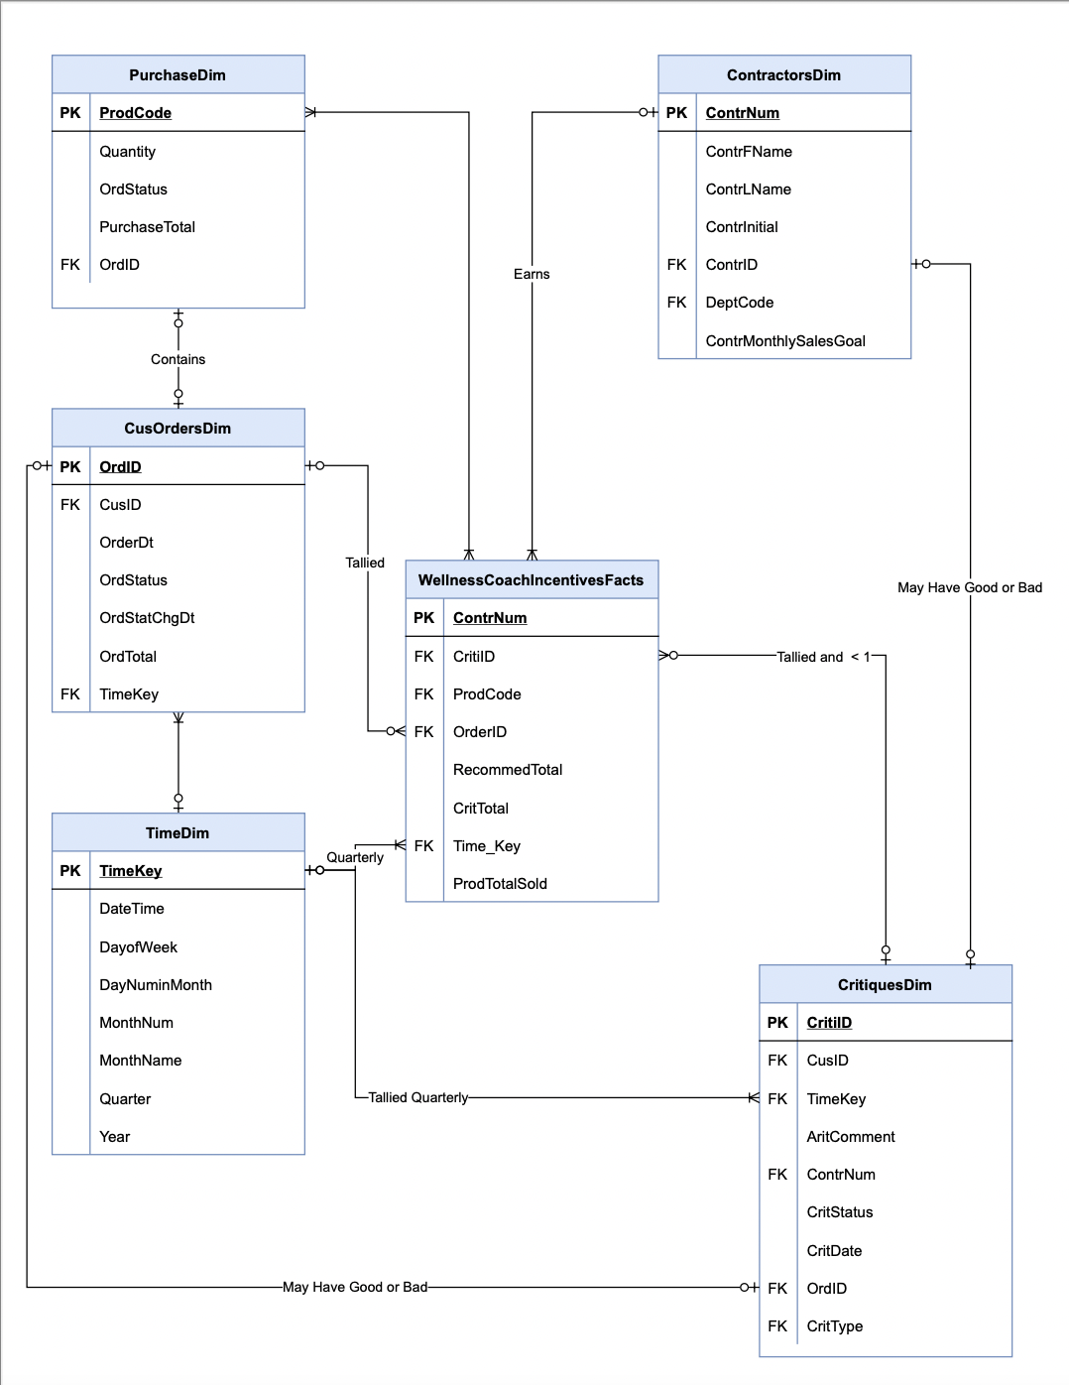

This is a conceptual Star Schema from the Wellness Team that in practice could be used to determine agents who had no complaints and achieved approximately 150 sales per quarter. They would thus be considered top performers and would qualify for incentives as seen in the Wellness Dashboard further below. The breakdown of the tables are as follows:

* 1. **WellnessCoachIncentivesFacts:** This fact table is guided by the Primary Key ContrNum or Contractor Number which is linked to our Wellness Coach’s. Unique attributes in this dimension include CritTotal and RecommendTotal which are tallies of these critique types. There is also ProdTotalSold which tallies products sold for the agents. From there, the Foreign Keys, CritiID, OrderID, ProdCode and Time_Key link to our dimension tables which will be discussed individually. From this table, we can determine if the incentive was earned.
  2. **ContractorDim:** This Dimension will link the incentive to the wellness coach who is contracted by Team Wellness. It contains their basic information such as name and department code but also their monthly sales goal which must be achieved to earn the bonus.
  3. **CritiquesDim:** Critiques are both complaints and recommendations that occur at specific points in time and sometimes belong to wellness coaches. They are tallied in the facts table and disqualify wellness coaches from earning the incentive if received on a quarterly basis, which is why they are linked to the time dimension, to capture their occurrence. They are linked by Foreign Key to the Contractors dimension as well.
  4. **PurchaseDim:** Contains the Primary Key ProdCode which is linked to a Foreign Key on the fact able. From this we can confirm completed orders and their associated products.
  5. **CusOrderDim:** Is the order dimension which contains information such as order data, date and status. It is linked by Foreign Key to the Time and Critique's dimensions so it can be used as an additional validation source for both criteria’s of the incentive, sales and complaints. It is also liked to the purchase dimension by Foreign Key.
  6. **TimeDim:** This dimension identifies events in time, particularly orders and critiques. This is important because the incentives are earned over a quarterly period therefore sales and complaints are tallied based on their occurrence during those time frames.

**DASHBOARDS:**

 Our company will be using various dashboard modules to analyze company data and performance as efficiently as possible.

1. Our Customer and Revenue Dashboard will be used to monitor the locations, sex, and age of our customers. This customer information will assist our marketing team and help us decide where to locate future warehouse locations. This dashboard was created with a small amount of test data. We anticipate having approximately 10,000 unique customer accounts entered at our initial launch.

Revenue information is also on this view, so we can see our profit, percentage of revenue amount by order status, total amount received with each payment method and the count of payment methods by payment status.

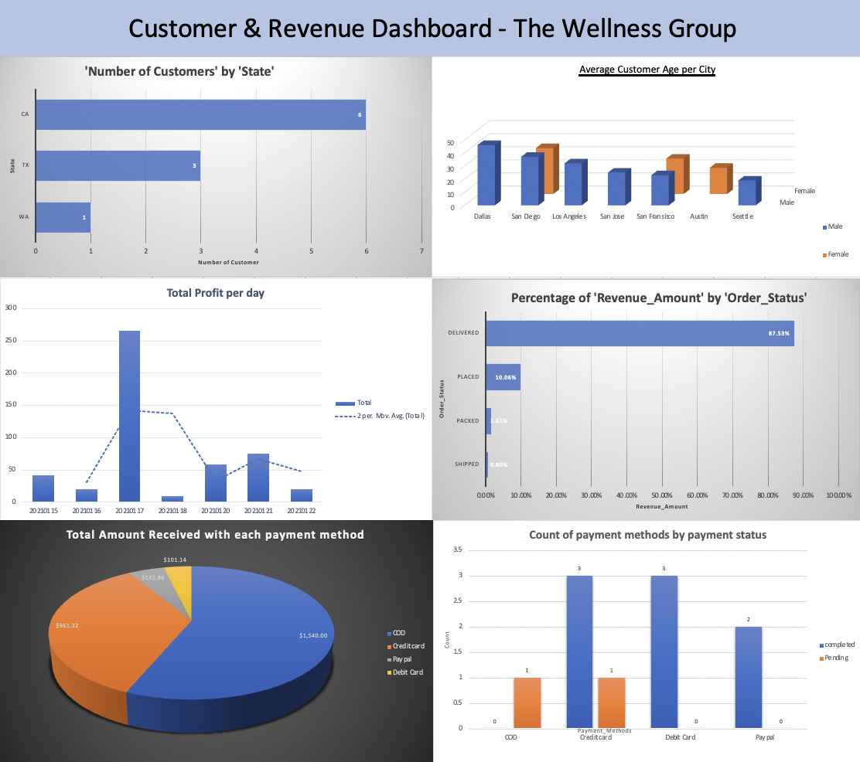

1. We will use an Inventory Dashboard to track our warehouse stock and monitor product expiration dates, as well as returns and total wholesale value of our warehouse stock. This way we can ensure we keep popular items in stock and monitor product quality.

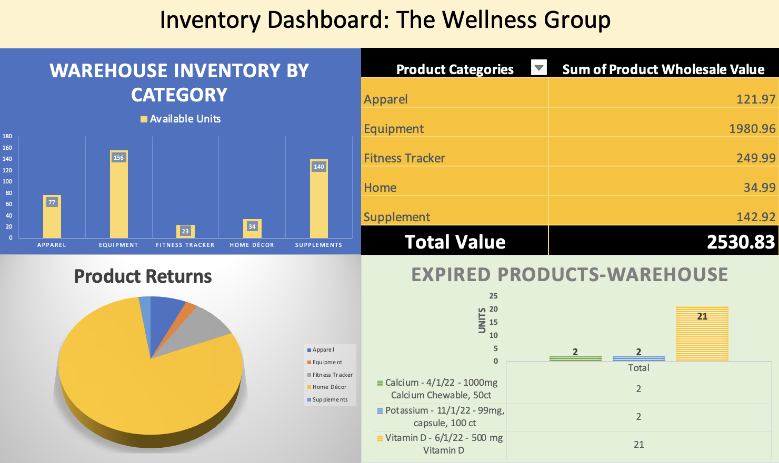

1. Performance incentives are a big part of The Wellness Team’s concept, as we want to reward our wellness coaches for good performance. These dashboard tools will help us monitor wellness coach performance. The working concept is that the Wellness Coaches will be rewarded with a bonus for achieving their sales goal and not having any complaints against them. The dashboard view below displays the incentive payouts by quarter as well as complaints and recommendations breakdown. There is also a top performers section showing employees who have sold more than 300 products year to date.

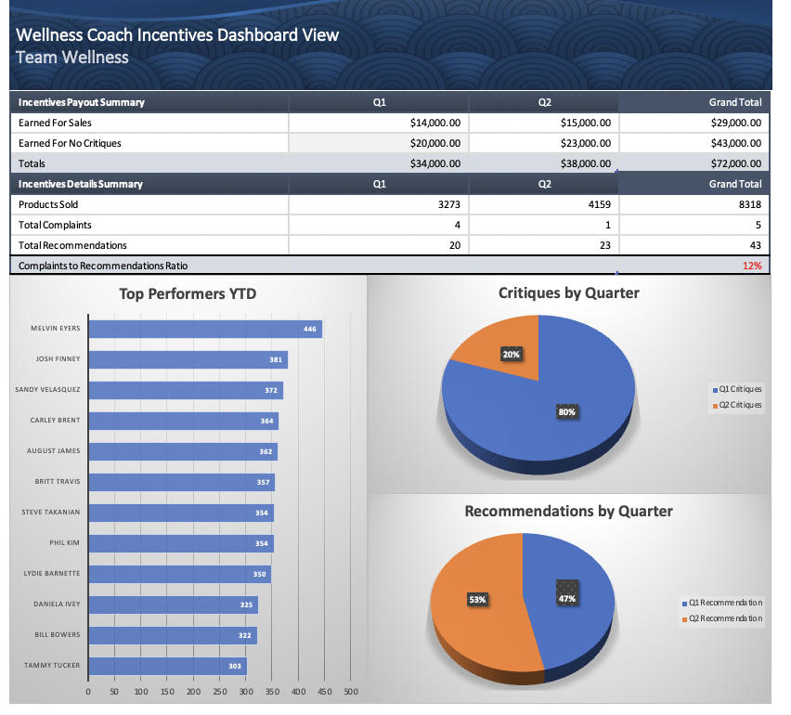

1. Customer surveys are important to our business as they help us understand what services our customers want (for example, what kind of supplements or exercise equipment they are interested in) and offer valuable insights that can help us build our business.

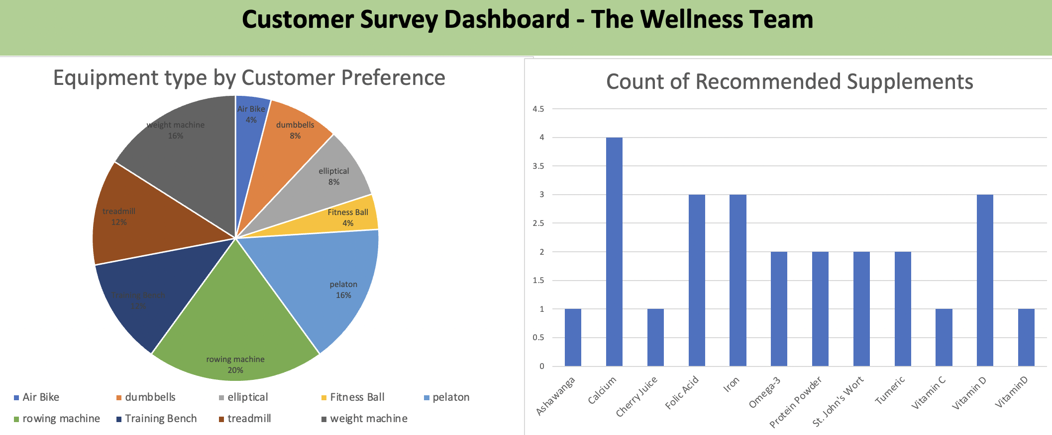

These are initial dashboard designs with a small amount of dummy data. Later we will adjust categories to allow for the most relevant and easy to reference categories.

For instance, in the “Count of Recommended Supplements” chart, we will group similar supplements into groups such as “Vitamins”, “Juice”, “Protein Products”, “Performance Enhancers” and “Herbs”.

All dashboard designs are subject to revision. Thank you for your consideration.

**APPENDIX 1: ERD DIAGRAM**

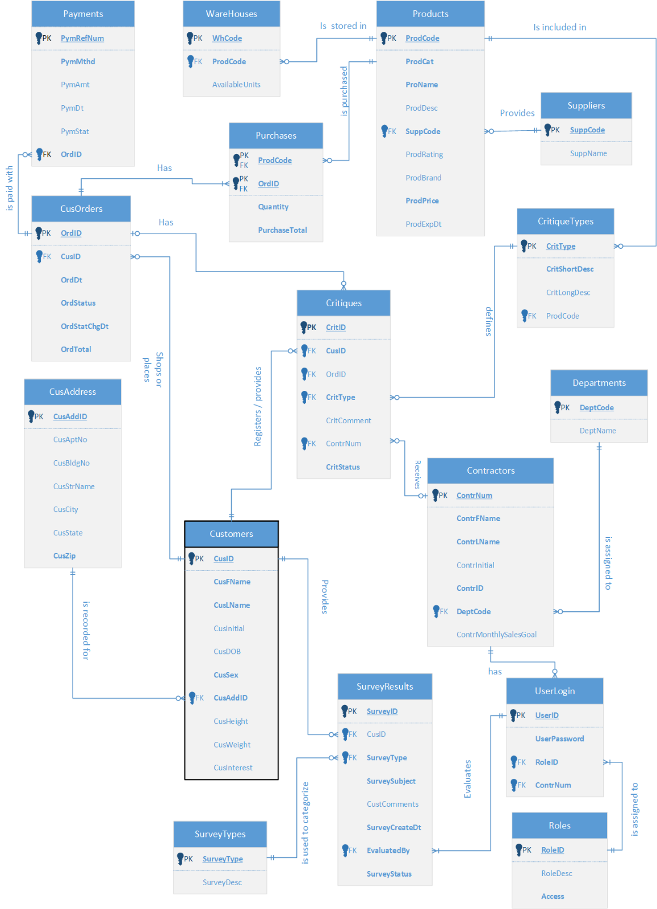

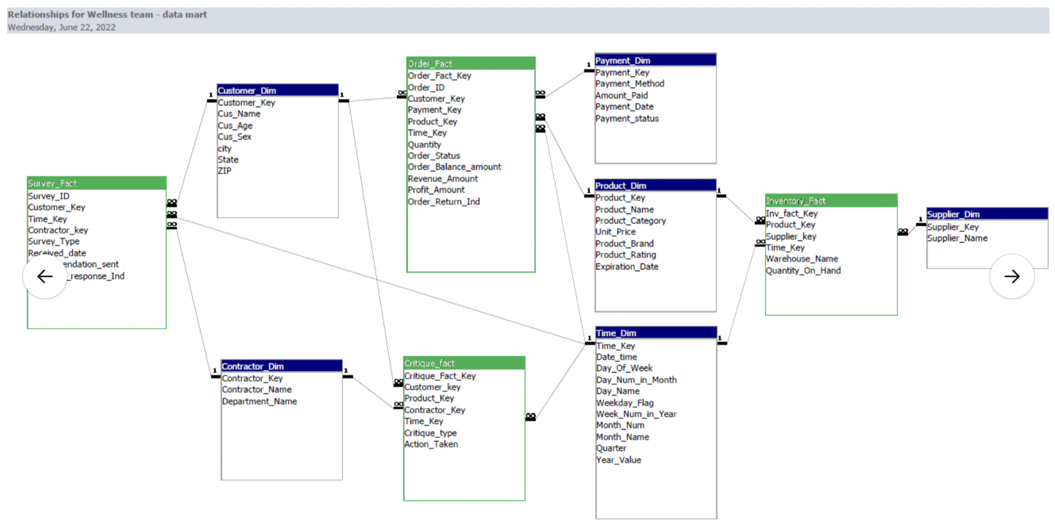**APPENDIX 2: DATAMART STAR SCHEMA**

**APPENDIX 3: WELLNESS COACH INCENTIVE SCHEMA**



**References**

1. Assessment: Could Supplements Help You? (n.d.). *WebMD.* Retrieved from <https://www.webmd.com/vitamins-and-supplements/supplements-assessment/default.htm>
2. Bowflex Insider Team. (2017, September 26). Find the Perfect Workout for Your Personality Quiz*. Bowflex.* Retrieved from - <https://www.bowflex.com/blog/perfect-workout-personality-quiz.html>
3. Clickstream Data Analysis Pipeline Using ksqlDB | Confluent Documentation. (n.d.). *Docs.confluent.io.* Retrieved from -<https://docs.confluent.io/platform/current/tutorials/examples/clickstream/docs/index.html>
4. E-commerce Workflow | Free E-commerce Workflow Templates. (n.d.). [*Www.edrawsoft.com*](http://Www.edrawsoft.com). Retrieved From - <https://www.edrawsoft.com/template-e-commerce-workflow.html>
5. How to Create a Social Media DFD Flowchart | Social Media Response DFD Flowcharts - diagramming software| Social Media Response | Media Flow Chart. (n.d.) *https://Www.conceptdraw.com* Retrieved from - <https://www.conceptdraw.com/examples/media-flow-chart>
6. Transmetrics. (May 2021) Top 5 Benefits of Integrating AI in Logistics. Blog. Retrieved from - <https://www.transmetrics.ai/blog/ai-in-logistics/>
7. Michał Drozdowicz (2008). Designing And Implementing Data Mart For An Agent-Based E-Commerce System. *IADIS International Journal*. Retrieved from <https://nationalu.brightspace.com/content/enforced/32006-ANA655-35752-2206/IADIS_2008_data_mart.pdf>
8. Matthews, Kelly. (2020, March) What is AI’s impact on real-time data?. *IoT Times*. Retrieved from - <https://iot.eetimes.com/what-is-ais-impact-on-real-time-data/>